21BDS0340

Abhinav Dinesh Srivatsa

Java

Lab Assessment 3

**Question 1**

Code:

import java.util.Scanner;

public class Question1 {

public static void main(String[] args) {

Scanner s = new Scanner(System.in);

int n = s.nextInt();

for (int x = 1; x <= n; x++) {

for (int y = 0; y < x; y++)

System.out.print("* ");

System.out.println("");

}

s.close();

}

}

Output:

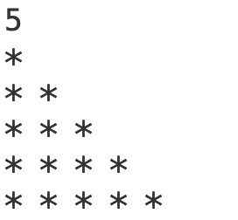

**Question 2**

Code:

import java.util.Scanner;

public class Question2 {

public static void main(String[] args) {

Scanner s = new Scanner(System.in);

int n = s.nextInt();

int arr[] = new int[n];

for (int x = 0; x < n; x++)

arr[x] = s.nextInt();

int diff, num1 = 0, num2 = 0, min = Integer.MAX_VALUE;

for (int x = 0; x < n - 1; x++)

for (int y = x + 1; y < n; y++) {

diff = Math.abs(arr[x] + arr[y]);

if (diff < min) {

min = diff;

num1 = arr[x];

num2 = arr[y];

}

}

System.out.println(num1 + "\n" + num2);

s.close();

}

}

Output:

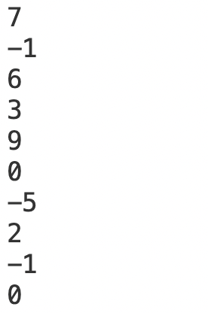

**Question 3**

Code:

import java.util.Scanner;

public class Question3 {

public static void main(String[] args) {

Scanner s = new Scanner(System.in);

int n = s.nextInt();

int mat[][] = new int[n][n];

for (int x = 0; x < n; x++)

for (int y = 0; y < n; y++)

mat[x][y] = s.nextInt();

for (int x = 0; x < n; x++) {

int temp = mat[x][n - x - 1];

mat[x][n - x - 1] = mat[x][x];

mat[x][x] = temp;

}

for (int x = 0; x < n; x++) {

for (int y = 0; y < n; y++)

System.out.print(mat[x][y] + " ");

System.out.println("");

}

s.close();

}

}

Output:

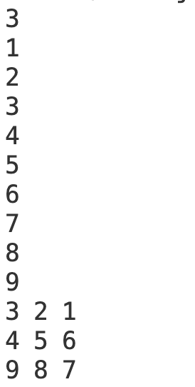

**Question 4**

Code:

import java.util.Scanner;

public class Question4 {

public static void main(String[] args) {

Scanner s = new Scanner(System.in);

int m = s.nextInt(), n = s.nextInt();

int mat[][] = new int[m][n];

for (int x = 0; x < m; x++)

for (int y = 0; y < n; y++)

mat[x][y] = s.nextInt();

int sum[] = new int[m];

for (int x = 0; x < n; x++) {

for (int y = 0; y < m; y++) {

System.out.print(mat[y][x] + " ");

sum[y] += mat[y][x];

}

System.out.println("");

}

System.out.println("----");

for (int x = 0; x < m; x++)

System.out.print(sum[x] + " ");

s.close();

}

}

Output:

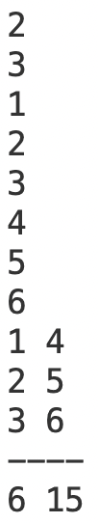

**Question 5**

Code:

import java.util.Scanner;

public class Question5 {

public static void main(String[] args) {

Scanner s = new Scanner(System.in);

String str = s.nextLine().trim();

String words[] = str.split(" ");

int count = 0;

for (int x = 0; x < words.length - 1; x++) {

boolean flag = true;

for (int y = x + 1; y < words.length; y++)

if (words[x].equals(words[y]))

flag = false;

if (flag)

count++;

}

System.out.println(count + 1);

s.close();

}

}

Output:



**Question 6**

Code:

import java.util.Scanner;

public class Question6 {

public static void main(String[] args) {

Scanner s = new Scanner(System.in);

int a1 = s.nextInt(), a2 = s.nextInt(), b1 = s.nextInt(), b2 = s.nextInt();

System.out.println(a1 + "+" + a2 + "i");

System.out.println(b1 + "+" + b2 + "i");

System.out.println((a1 + b1) + "+" + (a2 + b2) + "i");

System.out.println((a1 - b1) + "+" + (a2 - b2) + "i");

s.close();

}

}

Output:

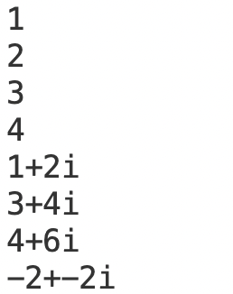

**Question 7**

Code:

import java.util.Scanner;

public class Question7 {

public static void main(String[] args) {

Scanner s = new Scanner(System.in);

String word = s.next();

StringBuilder sb = new StringBuilder(word);

String rep = s.next();

int t1 = s.nextInt(), f1 = s.nextInt();

int t2 = s.nextInt(), f2 = s.nextInt();

sb.replace(t1, f1, rep);

System.out.println(word + "\n" + sb);

sb.delete(t2, f2);

System.out.println(sb);

s.close();

}

}

Output:

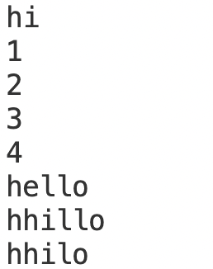

**Question 8**

Code:

import java.util.Scanner;

public class Question8 {

public static void main(String[] args) {

Scanner s = new Scanner(System.in);

Cow cow = new Cow(s.next(), s.next());

Cat cat = new Cat(s.next(), s.next());

Dog dog = new Dog(s.next());

cow.displaySound();

cat.displaySound();

dog.display();

s.close();

}

}

class Animal {

String type = "Animal";

String sound = "Sound";

String eat = "Food it likes";

}

class Cow extends Animal {

String name = "Cow";

Cow(String sound, String eat) {

this.sound = sound;

this.eat = eat;

}

void displaySound() {

System.out.println(this.name + " makes a " + this.sound + " sound and eats " + this.eat);

}

}

class Cat extends Animal {

String name = "Cat";

Cat(String sound, String eat) {

this.sound = sound;

this.eat = eat;

}

void displaySound() {

System.out.println(this.name + " makes a " + this.sound + " sound and eats " + this.eat);

}

}

class Dog extends Animal {

String name;

Dog(String name) {

this.name = name;

}

void display() {

System.out.println(this.name + " is the dogs name");

}

}

Output:

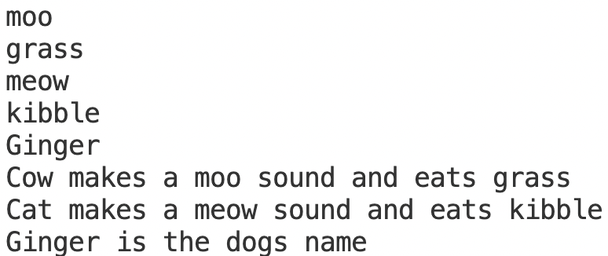

**Question 9**

Code:

import java.util.Scanner;

public class Question9 {

public static void main(String[] args) {

Scanner s = new Scanner(System.in);

Truck t = new Truck(s.next(), s.nextInt());

Car c = new Car(s.next(), s.nextInt());

t.display();

t.vehicleManufacturer();

c.display();

c.vehicleManufacturer();

s.close();

}

}

class Vehicle {

String purpose;

int wheels;

void vehicleManufacturer() {

System.out.println("The name of the vehicle manufacturer is Benz.");

}

}

class Truck extends Vehicle {

String name = "Truck";

Truck(String purpose, int wheels) {

this.purpose = purpose;

this.wheels = wheels;

}

void display() {

System.out.println(this.name + " has " + this.wheels + " wheels and is used for " + this.purpose);

}

void vehicleManufacturer() {

System.out.println("The name of the vehicle manufacturer is Tata");

}

}

class Car extends Vehicle {

String name = "Car";

Car(String purpose, int wheels) {

this.purpose = purpose;

this.wheels = wheels;

}

void display() {

System.out.println(this.name + " has " + this.wheels + " wheels and is used for " + this.purpose);

}

void vehicleManufacturer() {

System.out.println("The name of the vehicle manufacturer is Jaguar");

}

}

Output:

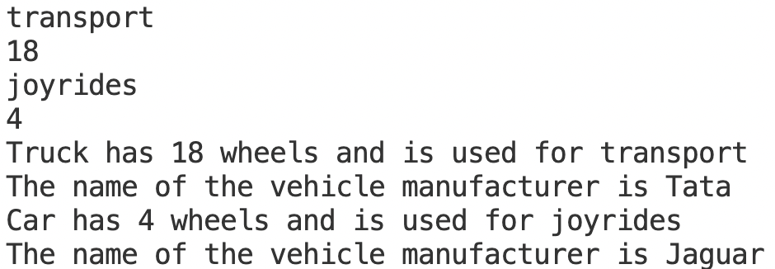

**Question 10**

Code:

import java.util.Scanner;

public class Question10 {

public static int mult(int a, int b) {

return a * b;

}

public static float mult(float a, float b) {

return a * b;

}

public static double mult(double a, double b) {

return a * b;

}

public static int sub(int a, int b) {

return a - b;

}

public static float sub(float a, float b) {

return a - b;

}

public static double sub(double a, double b) {

return a - b;

}

public static void main(String[] args) {

Scanner s = new Scanner(System.in);

System.out.println(mult(s.nextInt(), s.nextInt()) + "\n" + mult(s.nextFloat(), s.nextFloat()) + "\n"

+ mult(s.nextDouble(), s.nextDouble()));

System.out.println(sub(s.nextInt(), s.nextInt()) + "\n" + sub(s.nextFloat(), s.nextFloat()) + "\n"

+ sub(s.nextDouble(), s.nextDouble()));

s.close();

}

}

Output:

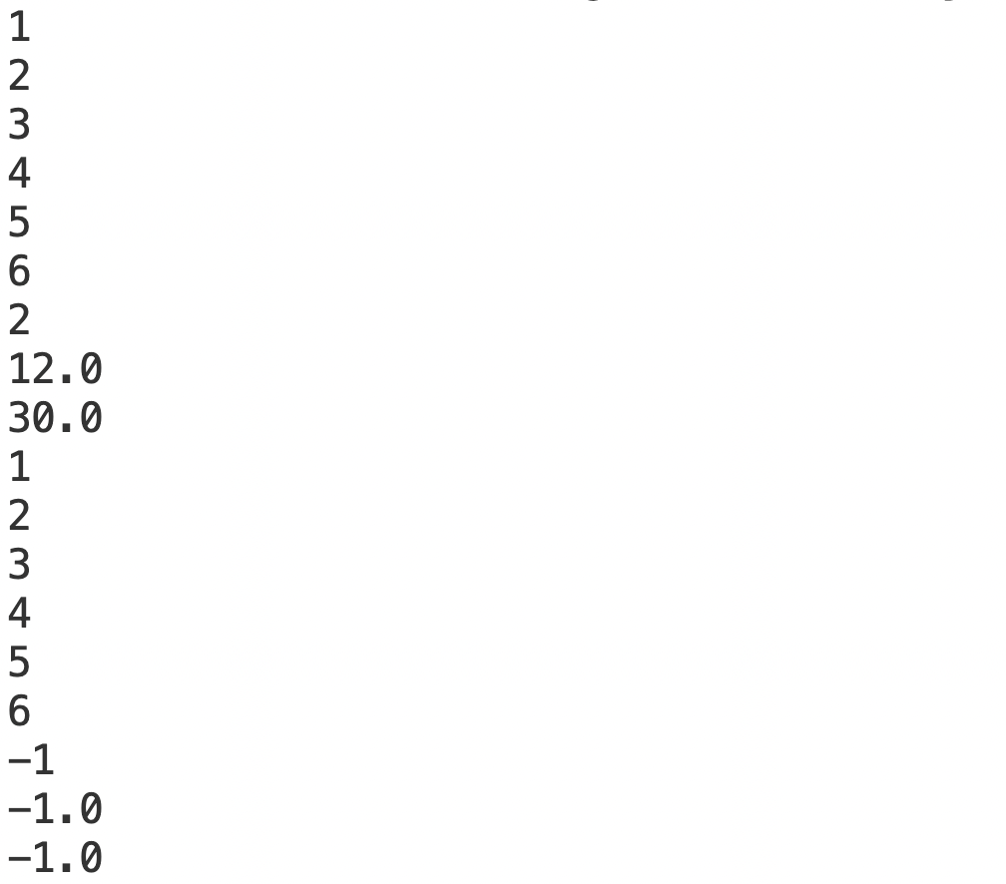

**Question 11**

Code:

import java.util.Scanner;

public class Question11 {

public static void main(String[] args) throws FirstDigitNotSameException {

Scanner s = new Scanner(System.in);

int a = s.nextInt(), b = s.nextInt();

s.close();

while (a / 10 != 0)

a /= 10;

while (b / 10 != 0)

b /= 10;

if (a != b)

throw new FirstDigitNotSameException("First digits of numbers are not same");

}

}

class FirstDigitNotSameException extends Exception {

FirstDigitNotSameException(String s) {

super(s);

}

}

Output:

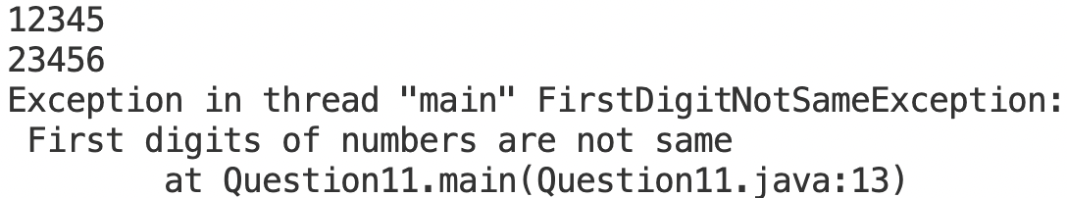

**Question 12**

Code:

import java.util.Scanner;

import printstring.PrintString;

public class Question12 {

public static void main(String[] args) {

Scanner s = new Scanner(System.in);

PrintString ps = new PrintString();

ps.display(s.next());

s.close();

}

}

printstring/PrintString.java

package printstring;

public class PrintString {

public void display(String s) {

System.out.println(s);

}

}

Output:



**Question 13**

Code:

import java.util.Scanner;

import mypack.math.Complex;

public class Question13 {

public static void main(String[] args) {

Scanner s = new Scanner(System.in);

Complex c1 = new Complex(s.nextDouble(), s.nextDouble());

Complex c2 = new Complex(s.nextDouble(), s.nextDouble());

Complex sum = c1.add(c2);

Complex diff = c1.sub(c2);

System.out.println("Sum: " + sum.toString());

System.out.println("Difference: " + diff.toString());

s.close();

}

}

mypack/math/Complex.java

package mypack.math;

public class Complex {

double a, b;

public Complex(double a, double b) {

this.a = a;

this.b = b;

}

public Complex add(Complex c) {

return new Complex(a + c.a, b + c.b);

}

public Complex sub(Complex c) {

return new Complex(a - c.a, b - c.b);

}

public String toString() {

return Double.toString(a) + "+" + Double.toString(b) + "i";

}

}

Output:

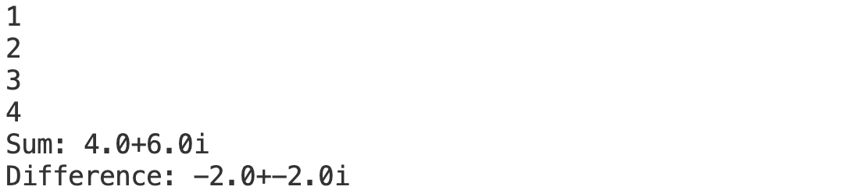

**Question 14**

Code:

import java.io.File;

import java.io.PrintWriter;

import java.util.Scanner;

public class Question14 {

public static void main(String[] args) {

Scanner s = new Scanner(System.in);

try {

PrintWriter pw = new PrintWriter(new File("Sample.txt"));

pw.write("This is part of Assessment - 3\nAbhinav Dinesh Srivatsa\n21BDS0340");

pw.close();

} catch (Exception e) {

System.out.println(e.getMessage());

}

s.close();

}

}

Output:

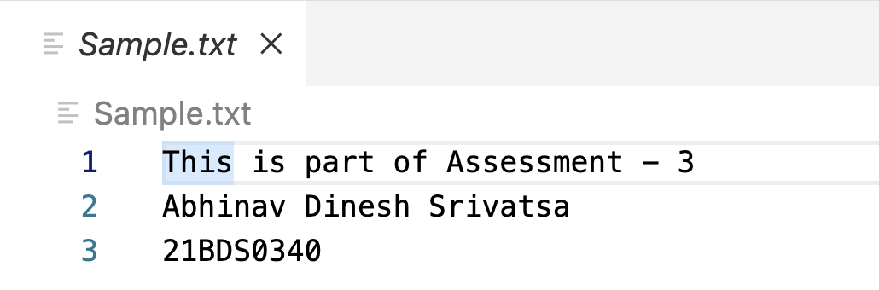

**Question 15**

Code:

import java.io.File;

import java.util.Scanner;

public class Question15 {

public static void main(String[] args) {

try {

Scanner s = new Scanner(new File("Sample.txt"));

while (s.hasNext())

System.out.println(s.nextLine().trim());

s.close();

} catch (Exception e) {

System.out.println(e.getMessage());

}

}

}

Output:

